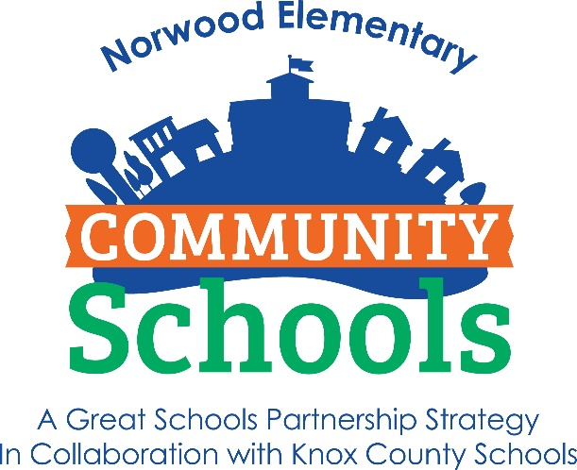

Norwood COMMUNITY SCHOOL:

The Big Questions

**WHO is part of the Community School?**

Every student who attends Norwood Elementary is a part of the Community Schools initiative.

**WHAT is a Community school?**

Community Schools is an idea, a strategy, a way of thinking. The Community Schools initiative turns public schools into hubs for resources that can be used by the school and the community. We partner with businesses, organizations, and people in Knoxville to make sure every student has an opportunity to learn and succeed.

**WHEN is the Community School open?**

We are active 24/7. Partners provide afterschool programming, school-day services, and even weekend and holiday support. The Community Schools initiative never closes because you can’t close a strategy!

**WHERE is the Community School located?**

Our Community School serves Norwood Elementary School. We organize resources and support for our students and teachers in the school. But we also work with families and residents in the Norwood neighborhood because safe, healthy neighborhoods build strong, successful schools!

**WHY do we need Community Schools?**

Every student, family, and community is unique. The Community Schools initiative celebrates those differences by recognizing that different schools need different resources to succeed.

**HOW does a Community School work?**

We listen to students, teachers, and community members to learn what is needed.

Then, we contact Partners to help out. Our partners are businesses, organizations, and individual people who want to support students and schools. They provide that support through mentors, donations, and programming.